In this document, short videos illustrating how to use the website https://purop.birzeit.edu/ are presented. Click on a link and you will be forwarded to the corresponding video.

Stage 1: creating accounts, forming research group and submitting projects
- Signing-up:
All members of the research group must create an account first. For account activation, a code will be sent to your email. If you do not receive it, please send an email to purop@birzeit.edu and your account will be activated manually.
- Palestinian supervisor signing-up
- External supervisor signing-up
- Student signing-up and uploading necessary documents
- Create a project:
Projects may be created by either a Palestinian or an external supervisor. Those created by an external supervisor will appear under the “Projects Seeking Partners” tab and can be selected by a Palestinian supervisor. Before doing so, the Palestinian supervisor must communicate with the external supervisor, discuss the project, and agree on the general guidelines. Next are the links of creating a project according to the supervisor and subsequent steps.
Palestinian supervisor can:
- Create a project and link the students.
- Adapt a project from “Projects Seeking Partners” list, and link the students.
When finished, the project will appear under the “Project Proposals for the New Call” tab.
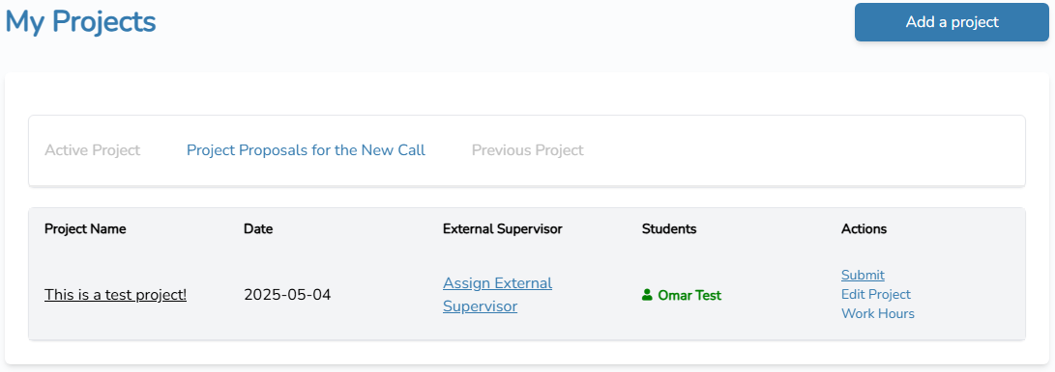
External supervisor can:
- Create a project
Student action:
- Accept/reject the invitation to join a project.
Students who accept the invitation will appear in green in the supervisor page.
- After forming the research group and connecting all its members, the Palestinian supervisor can submit the project. He should verify that all students have accepted the connection (students who accept the invitation will appear in green, as shown in the next screenshot)
2
1
- After the deadline for submitting project proposals is reached, the PalUROP advisory board will review the applications, and email notifications will be sent to the Palestinian supervisors of the approved projects. These projects will then be moved to the “Active Project” tab
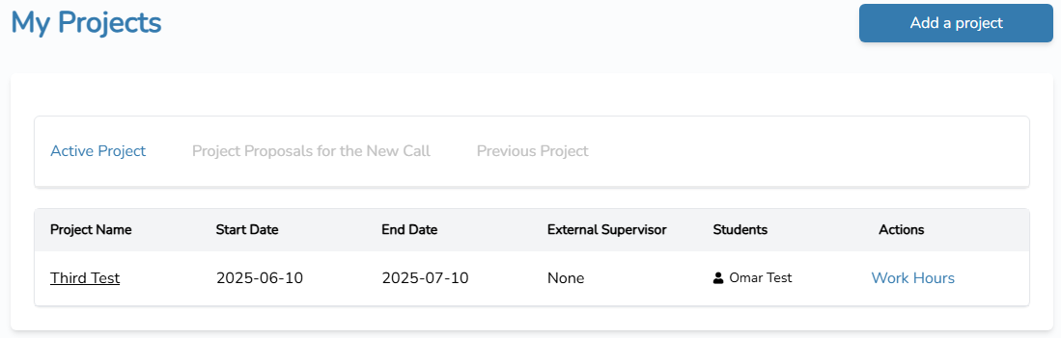

Stage 2: Logging students’ working hours.
Once the research proposal has been approved, the research group can start working on the project, and students can log their working hours. The following links provide short videos illustrating this on the website.
Note that the student will not be able to log working hours unless he has uploaded all the required documents to his profile page (see the next figure), as explained in the link previously provided for students’ sign-up.
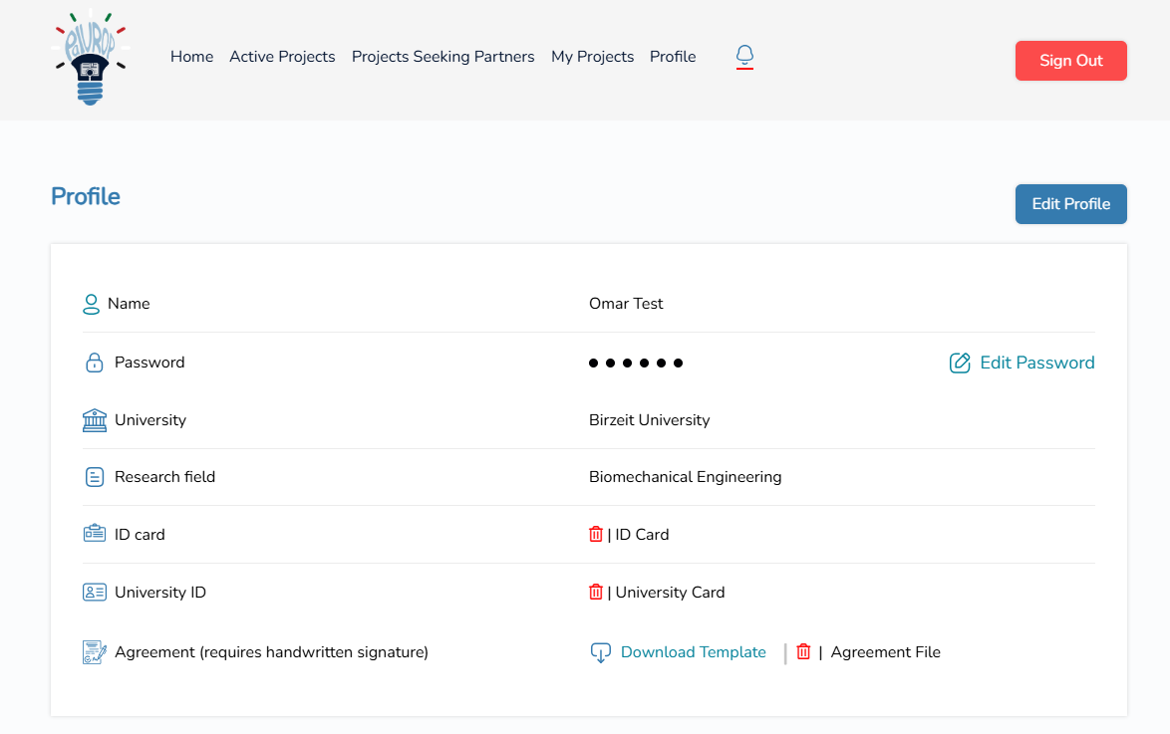
- Adding working hours by the student. Both the Palestinian and external supervisors will be notified automatically by email each time the student logs working hours.
- Approving logged hours by the supervisor (can be done by either the Palestinian or the external supervisor).

Stage 3: Closing the project.
At the end of the project cycle – indicated in the announcement files – research group members should finalize their work, students should log their last working hours, submit the final report, and supervisors should close their projects. Supervisors will not be able to close their project unless they have uploaded the required document in their profile tab on the website.
After closing the project, the process of students’ compensation will be initiated.

As the website is under continuous development, some of the fields appearing in the short videos have been modified and others have been removed entirely. However, the procedure remains the same.

